Wesham Town Council Monthly Meeting to be held on Tuesday, 18th July 2023
at 7.30pm in the Committee Room, Wesham Community Centre.

AGENDA

APOLOGIES:

CODE OF CONDUCT AND STANDING ORDERS
Members are reminded of the standard of conduct they must adhere to during Town Council meetings.

DECLARATION OF INTERESTS:
Members are reminded that any direct or indirect pecuniary or other interests should be declared as required by the Council’s Code of Conduct for Members.

23/055 APPROVAL OF THE MINUTES OF THE COUNCIL MEETING HELD 20th June 2023

23/056 MATTERS ARISING – any item not covered by agenda or action list

- Co-option of Wesham Councillors – interviews 11th July 2023
- Resignation of Cllr L Walker – 26th June 2023
- Acknowledgement of recently retired councillors

23/057 POLICING ISSUES - none noted to review since 20th June 2023
- Crime Reports – police.org.uk website > area > PR4 3DR (WCC postcode)
- Policing Issues – to discuss any items raised by Councillors

23/058 PLANNING -
- Planning Applications -

23/0256 – Bobsleigh, 6 Mowbreck Lane, Wesham

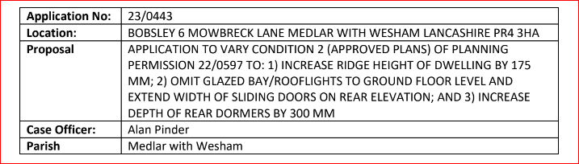

23/0442 – 22 West View, Wesham

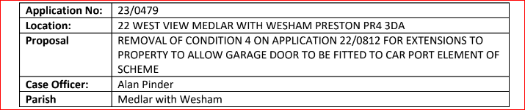

- Planning Consultation - E-mail 28/06/2023
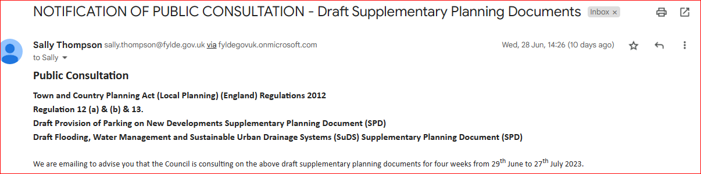

FLOODING
- Road Drainage
- Crossing Gates
- Sanderling Way
KJFC Drainage report
23/059 PLAYING FIELDS and OPEN SPACES -
- Open Spaces Contract - to discuss any issues raised by Councillors
- Summer Bedding update from RP & Cllr L Nulty
- Grounds maintenance SLA Review meeting with RP @ 7pm

- Fleetwood Road Playing Fields - to discussed any issues raised
- KJFC Rent for 2023
- Doorstep Green, Derby Road - to discussed any issues raised.
- Trees maintenance on Derby Road – NHS hospital estates area
- Street Cleaning in Wesham - nothing for July 2023 mtg
- Allotments
Moreland Ave Allotment Tenant request
- Waiting list – Re-advertise as post in 2017. Suggest an “open-day” to invite people to the allotments and meet current holders.
- Drainage problems – Recent flooding to allotments and gardens (Douglas Avenue). Riparian ditch is not functioning – highlighted on aerial map below.
- Additional tap – Near Plot 32 as shown on map below.
- Neglected plots – As mentioned before we would like to help people take these plots on – highlighted red.
- Composting toilet
- Mowing central path
- Skip to clear neglected plots
- Woodland area next to Plot 31 – Is this land part of the allotments and can I/we clear low lying vegetation and rubbish to use as a social space? Circled red on map.
Allotment Meeting date ?
- Wesham Bowling Club –
Ownership of the Bowling Green & Peppercorn Rent
- Dog PSPO extension Alcohol PSPO extension – consultation now ended

23/060 HIGHWAYS AND RAILWAYS – to discussed any issues raised

23/061 GOVERNANCE, FINANCE AND INSURANCE

Accounts payable and income received report –

WTC Monthly summary – June 2023
- Update to Signatories on Bank system
- Quicker payment options

Freckleton Marsh Chq – Proposal for Benches ?

Accident and Incident Reporting – none

- WTC/WCC equipment – update Cllr D Nowell

23/062 EVENTS -
- Community Club Day Field Event

23/063 HUMAN RESOURCES
- HR sub Committee – update?
- WCC Manager – LM

23/064 WESHAM COMMUNITY CENTRE
- Heating system repairs WCC – Updates
- Bollard repairs

23/065 OTHER
- Website
- Actions

DATE OF NEXT WTC monthly meetings: –
18th July 2023
19th Sept 2023
17th Oct 2023

WTC Additional Meetings
Date | Meeting
11th July 2023 | Co-option WTC Councillor interviews
18th July 2023 | WTC Monthly meeting
20th July 2023 | Wesham Community Centre meeting
TBA | KJFC SLA 2nd meeting with Barry (signing SLA) ?
TBA | Allotment Meeting (Moreland Ave)

Angela Hunter Date: 11th July 2023

